
SRM Institute of Science and Technology
Mode of Exam
OFFLINE
College of Engineering and Technology
School of Computing
DEPARTMENT OF COMPUTING TECHNOLOGIES
SRM Nagar, Kattankulathur – 603203, Chengalpattu District, Tamilnadu
Academic Year: 2022 - 2023 - Odd Semester
Test: CLAT-3 SET A Date: 02.11.2023
Course Code & Title: 18CSE453T& NETWORK ROUTING ALGORITHMS Duration: 12:30 PM – 02:15 PM
Year & Sem: III /IV & V / VII Sem Max. Marks: 50

Course Articulation Matrix:
S.No. | Course Outcome | PO1 | PO2 | PO3 | PO4 | PO5 | PO6 | PO7 | PO8 | PO9 | PO10 | PO11 | PO12
1 | CO1 | H |  | M |  |  |  |  |  |  |  |  | M
2 | CO2 |  | M | L |  | H
3 | CO3 |  | H | L | H
4 | CO4 | M | H | H
5 | CO5 |  | H |  | H | H
6 | CO6. |  | H |  | H | H

Part - A
(10 * 1 = 10 Marks)
Instructions: Answer all the Questions
Q. No | Question | Marks | BL | CO | PO | PI Code
1 | Which protocols does allow routers to work with less information about the network area?  a. Link State Protocols  b. Distance Vector Protocols  c. Path-Vector Protocols  d. Hybrid Protocols | 1 | 2 | 4 | 1 | 1.4.1
2 | Border Gateway Protocol (BGP) use the hop-count for shortest path, but hop-count in BGP’s case is a ________  a.router  b.Autonomous System  c. switch  d.BGP don’t use Hop-count | 1 | 2 | 4 | 1 | 1.4.1
3 | How many hop count restrictions are in Open Shortest Path First Protocol?  a. 10  b. 15  c. 20  d. 25 | 1 | 2 | 4 | 2 | 2.1.1
4 | Which of the following is a Cisco-proprietary distance-vector routing protocol ?  a.OSPF  b.RIPv2  c.IGRP  d.BGP | 1 | 1 | 4 | 1 | 1.4.1
5 | The default hope count for EIGRP are ?  a.100  b.120  c.160  d.255 | 1 | 1 | 4 | 1 | 1.4.1
6 | Which one of the following statements is true that could identify with pure flooding?  a. every node transmits the request only once  b. every node broadcast the request only once  c. every node forwards the request multiple times  d. every node broadcasts the request multiple times | 1 | 1 | 5 | 1 | 1.4.1
7 | Specify the ranges on relatively small network diameter with respect to Dynamic Source Routing (DSR).  a. 2 – 5 hops  b. 5 – 10 hops  c. 15 – 20 hops  d. 20 – 25 hops | 1 | 2 | 5 | 2 | 2.1.1
8 | QoS Parameters are  a.Bandwidth, packet delivery ratio, jitter  b.Network load, Number of Nodes, power Consumption  c.Latency, Mobility, Efficiency  d.Delay, Mobility, jitter | 1 | 2 | 5 | 1 | 1.4.1
9 | What is the distance, that would be specified in the routing table at node 5 with respect to destination 0 and next hop 2?  a. 1  b. 2  c. 3  d. 4 | 1 | 3 | 5 | 2 | 2.4.1
10 | What will happen, when a neighbor node perceives a link break at a particular node?  a. it sets all routes through broken link to ∞  b. it sets all routes through broken link to 0  c. it sets all routes through broken link to 1  d. it sets all routes through broken link to negative value | 1 | 2 | 5 | 1 | 1.4.1

Part - B
(4* 10 = 40 Marks)
Instructions: Answer the Questions
Q. No | Question | Marks | BL | CO | PO | PI Code
11.a | State the three basic functions on how routing protocols work and describe in detail about Border Gateway Protocol with a neat sketch.  BGP decision process can be divided into two parts:  1.path selection and  2. Aggregation and dissemination  - The BGP path selection process has the responsibility of selecting routes to various IP prefix destinations for use locally by a BGP speaker. The BGP path selection process is part of the overall BGP decision process, which also handles route dissemination to its neighboring BGP peer speakers;  - To accomplish route selection, each BGP speaker maintains two routing information bases (RIBs):  - Adjacent RIBs-In (Adj-RIBs-In) is the information base that stores AS-level routing information for each IP prefix it has learned about from its neighbors through inbound UPDATE messages.  - Loc-RIB is the information base that stores the routes that have been determined locally by its decision process, which is to be used for determining the forwarding table.  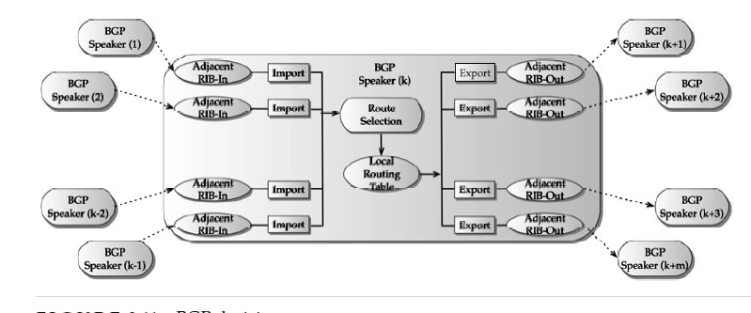 | 10 | 2 | 4 | 2 | 2.1.2
 | (OR)
11.b | Illustrate with an example, how shortest path for information exchange could be identified on Routing Information Protocol.  - RIP is the first routing protocol used in the TCP/IP-based network in an intra domain environment  - RIP described here is loosely based on the program routed, distributed  RIP remains one of the popular routing protocols for a small network environment.  - General packet handling: if any of the must-be-zero fields have nonzero values anywhere or if the version field is zero, the packet is discarded.  - Initialization: when a router is activated and it determines that all the interfaces are alive, and it broadcasts a request message that goes to all interfaces in the ‘request-ful’ mode. The neighboring routers handle responses following the split horizon rule. Once the responses are received, the routing table is updated with new routes the router has learned about.  - Normal routing updates: in the default case, this is done approximately every 30 sec (‘Autoupdate timer’) where updates are broadcasted with command fields set to the re-sponse mode; as discussed earlier about timer adjustment a large variation is added to avoid the pendulum effect.  - Normal response received: the routing table is updated by doing the distributed Bellman Ford step; only a single best route is stored for each destination.  - Triggered updates: if the metric for an addressable network changes, an update message is generated containing only the affected networks.  Route expiration: if an addressable network has not been updated for 3 min (‘expiration timer’) in the default case, its metric is set to infinity and it is a candidate for deletion. However, it is kept in the routing table for another 60 sec; this extra time window is referred to as garbage collection or ffush timer | 10 | 2 | 4 | 2 | 2.1.2
12.a | Describe the various packet formats used in the OSPF  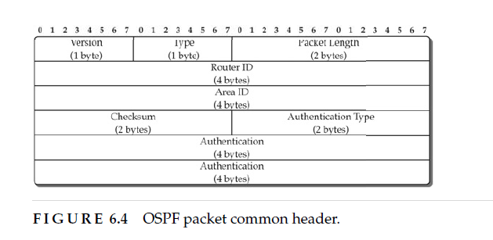  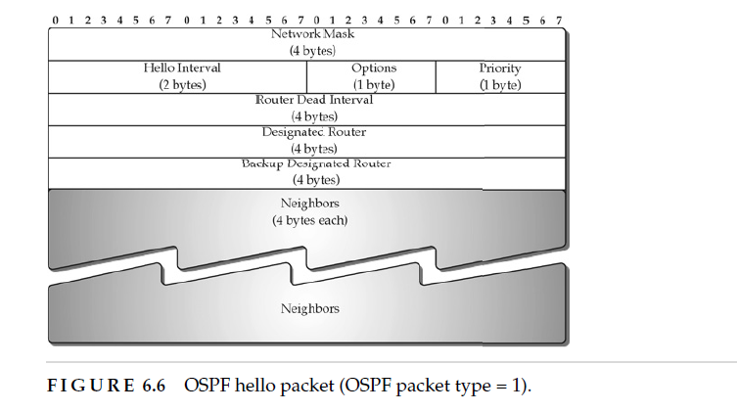 | 10 | 2 | 4 | 1 | 1.4.1
 | (OR)
12.b | Explain about seven steps of OSPF with necessary diagrams  - Network Hierarchy  - Router Classification  - Network Types  - Flooding  - Link State Advertisement Types  - Subprotocols  Routing Computation and Equal-Cost Multipath  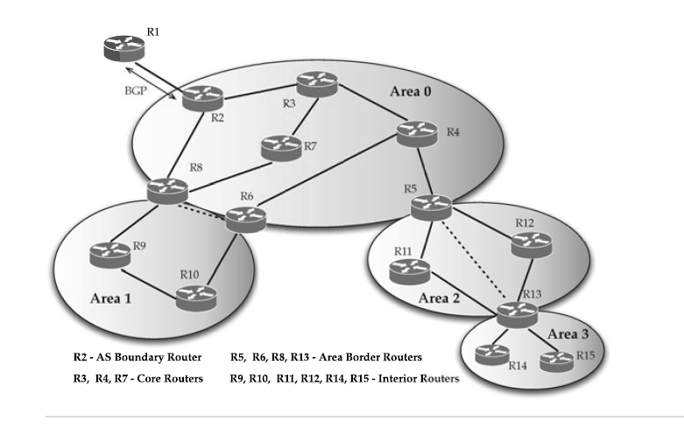 | 10 | 2 | 4 | 1 | 1.4.1
13.a | Draw a schematic sketch of Zone Routing Protocol and explain on how zone topology information exchange using route update packets.  This protocols uses a combination of proactive and reactive routing protocols:  - proactive: in the neighborhood of r hops: Intra-zone routing protocol (IARP);  - reactive: outside this zone: Inter-zone routing protocol (IERP).  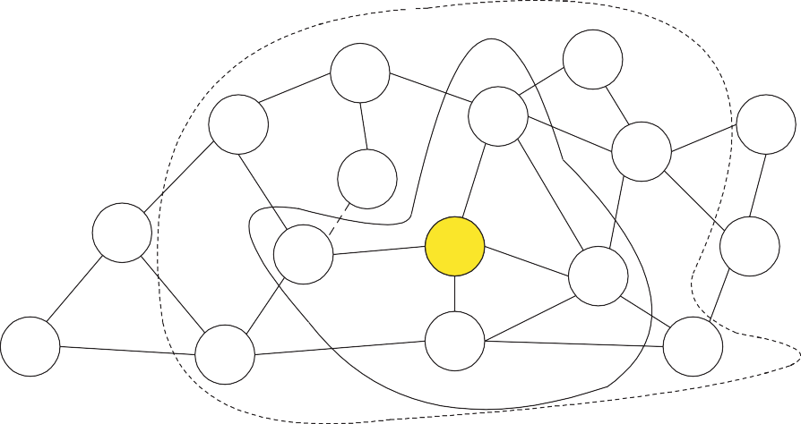  The protocol operates as follows:  - if the destination is within the zone, the source sends packets directly;  - if not, the destination sends RouteRequest to peripheral nodes;  - if any peripheral node, has the destination in its zone it replies with RouteReply;  - if not, peripheral nodes sends RouteRequest to their peripheral nodes and so on;  - if multiple RouteReply are received the best is chosen based on some metric.  If the broken link is detected:  - intermediate node repairs the link locally bypassing it (proactive routing!!!);  - end nodes are informed;  - sub-optimal pass but very quick procedure;  after several local reconfiguration, the source initiates global pass finding to find optimal | 10 | 2 | 5 | 2 | 2.1.2
 | (OR)
13.b | Explain in detail about Ad-Hoc Wireless Network and its Classification of various routing Protocol  - dynamically changing topology;  - absence of fixed infrastructure and centralized administration;  - bandwidth constrained wireless links;  - energy-constrained nodes.  The following are the main challenges:  - Movement of nodes:  - Path breaks;  - Partitioning of a network;  - Inability to use protocols developed for fixed network.  - Bandwidth is a scarce resource;  - Inability to have full information about topology;  - Control overhead must be minimized.  - Shared broadcast radio channel:  - Nodes compete for sending packets;  - Collisions.  - Erroneous transmission medium:  - Loss of routing packets.  - Proactive routing protocols  - Reactive routing protocols  - Hybrid routing protocols  - Hierarchial routing protocols  - Power-aware routing protocols | 10 | 2 | 5 | 2 | 2.1.2
14.a | Explain Hybrid Routing Protocols: Core Extraction Distributed Ad Hoc Routing Protocol  Core Extraction Distributed Ad Hoc Routing Protocol (CEDAR) ▪ CEDAR integrates routing and support for QoS. ▪ It is based on extracting core nodes (also called as Dominator nodes) in the network. ▪ Core nodes together approximate the minimum Dominating Set (DS). ▪ A DS of a graph is defined as a set of nodes such that every node in the graph is either present in the DS or is a neighbor of some node present in the DS. ▪ There exists at least one core node within every three hops. ▪ The nodes that choose a core node as their dominating node are called core member nodes of the core node concerned. ▪ The path between two core nodes is termed as virtual link. ▪ CEDAR employs a distributed Algorithm to select core nodes. ▪ The selection of core nodes represents the core extraction phase. ▪ CEDAR uses the core broadcast mechanism to transmit any packet throughout the network in the unicast mode, involving as minimum number of nodes as possible. ▪ Route Establishment in CEDAR: It is carried out in two phase. ▪ The first phase finds a core path from source to destination. The core path is defined as the path from dominator of the source node (source core) to the dominator of the destination node (destination core). ▪ In the second phase, a QoS feasible path is found over the core path. ▪ A node initiates a RouteRequest if the destination is not in the local topology table of its core node; otherwise the path is immediately established. ▪ For establishing a route, the source core initiates a core broadcast in which the RouteRequest is sent to all neighboring core nodes which inturn forwards it. ▪ A core node which has the destination node as its core member replies to the source core. ▪ Once the core path is established, a path with the requested QoS support is then chosen. A node after which the break occurred: o Sends a notification of failure. o Begins to find a new path from it to the destination. o Rejects every received packet till the moment it finds the new path to the destination. ▪ Meanwhile, as the source receives the notification message: o It stops to transmit. o Tries to find a new route to the destination. o If the new route is found by either of these two nodes, a new path from the source to the destination is established. Advantages ▪ Performs both routing and QoS path computation very efficiently with the help of core nodes. ▪ Utilization of core nodes reduces traffic overhead. ▪ Core broadcasts provide a reliable mechanism for establishing paths with QoS support. Disadvantages ▪ Since route establishment is carried out at core nodes, the movement of core nodes adversely affects the performance of the protocol | 10 | 2 | 4 | 2 | 2.1.2
 | (OR)
14.b | State the similarities between Wired and Wireless network. With neat graph on nodes, describe the following in associate with Cluster head gateway switch routing protocol (GGSR).  a. Gateway Node  b. Cluster Head  c. Source and Destination  - Cluster head gateway switch routing protocol (CGSR)  It is characterized by the following:  - nodes are organized into clusters, each having an elected cluster-head;  - cluster head provides a coordination within its transmission range (single hop);  - token-based scheduling is used within a cluster for sharing bandwidth between nodes;  - all communications pass through the cluster head;  - communication between cluster is done using the common nodes  - (gateways with two interfaces).  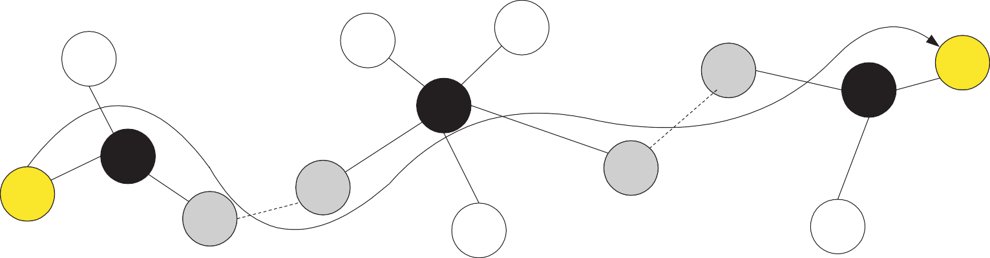  Two tables are used in CGSR:  - Cluster member table containing the destination cluster head for every node;  - Routing table containing the next-hop node for every destination cluster.  The protocol operates as follows:  - a node obtains a token from its cluster head;  - if this node has a packet to transmit, it determines the destination cluster head and next-hop;  - routed packet goes as follows:  – a − H₁ − G₁ − H₂ − G₂ − · · · − H_{i} − G_{i} − · · · − G_{n} − H_{n} − b: where  - G_{i} is the gateway i;  - H_{i} is the cluster head i.  Route reconfiguration happens when:  - there is a change in cluster heads;  - stale entries are in cluster member table or routing table. | 10 | 2 | 5 | 2 | 2.1.2

Course Outcome (CO) and Bloom’s level (BL) Coverage in Questions

